EXPERIMENT 1

Done By: Rohit Karunakaran
Roll No : 58
Date of submission: 7-5-2021

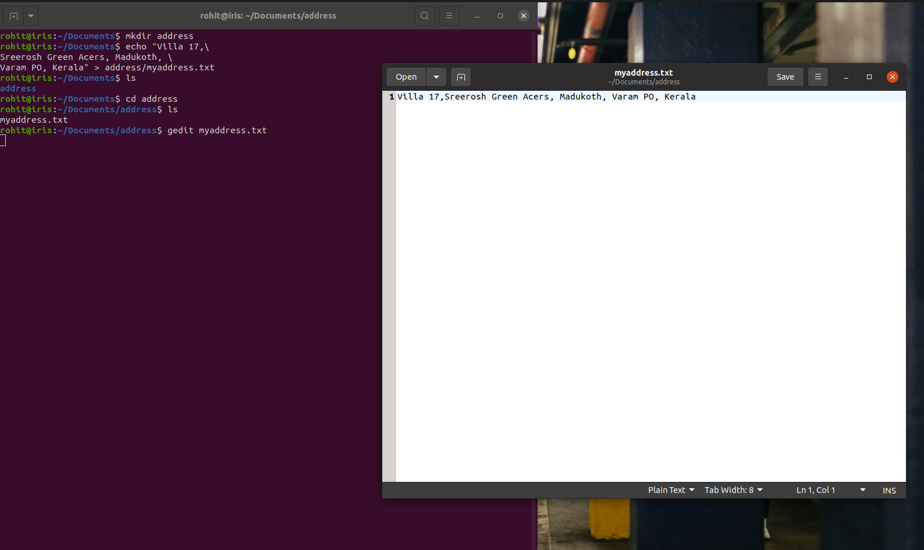
Exerise 1
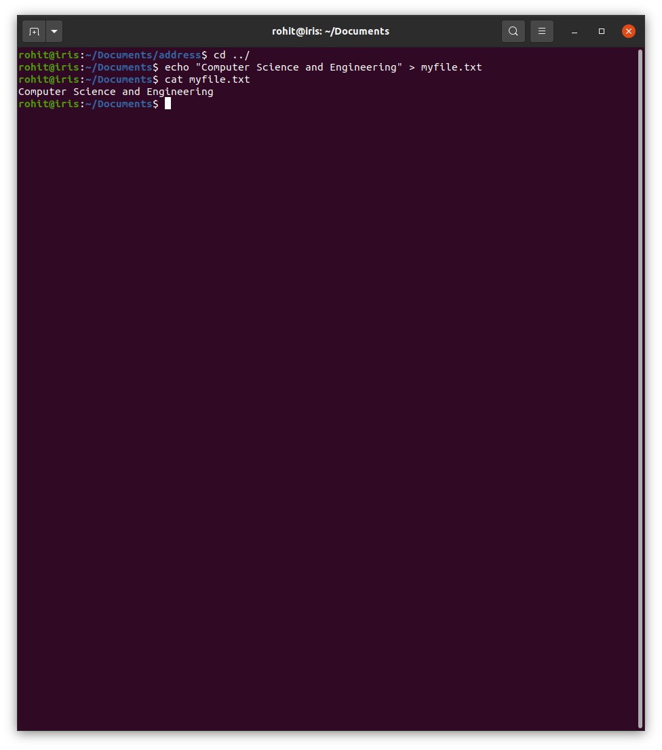
Exerise 2

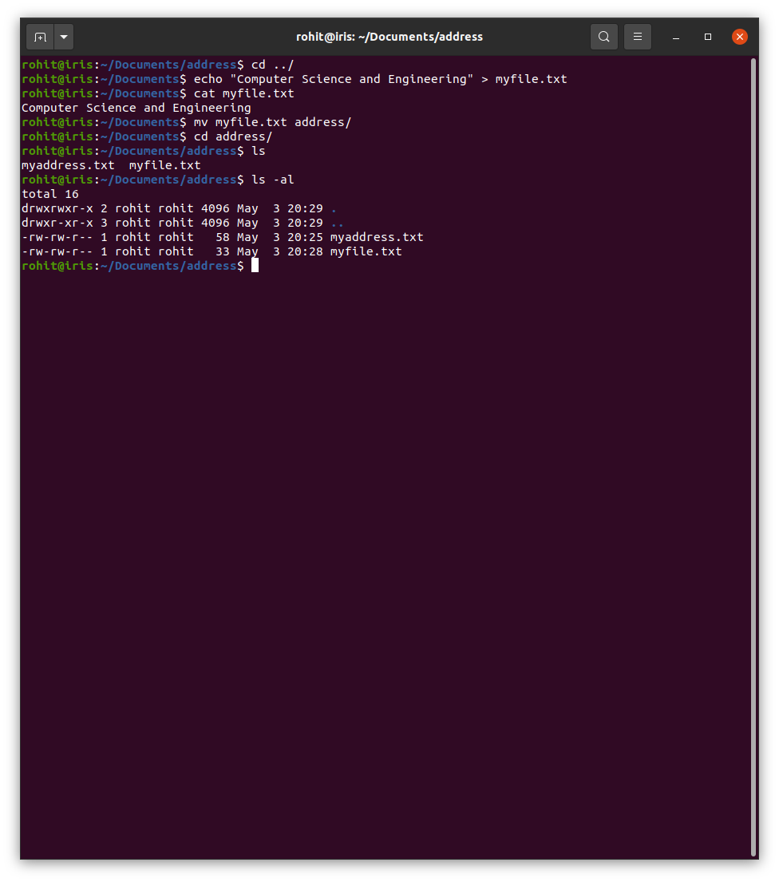
Exerise 3

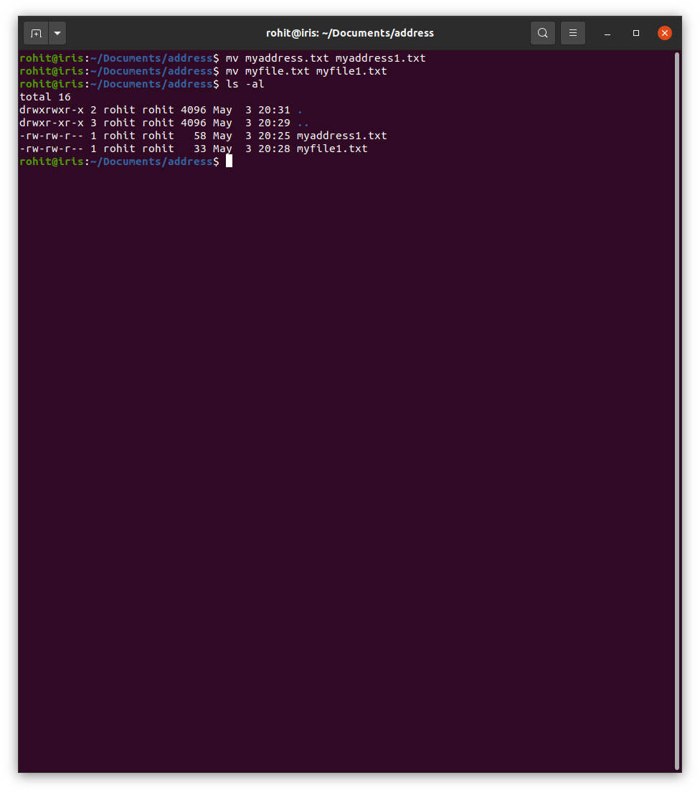
Exersie 4

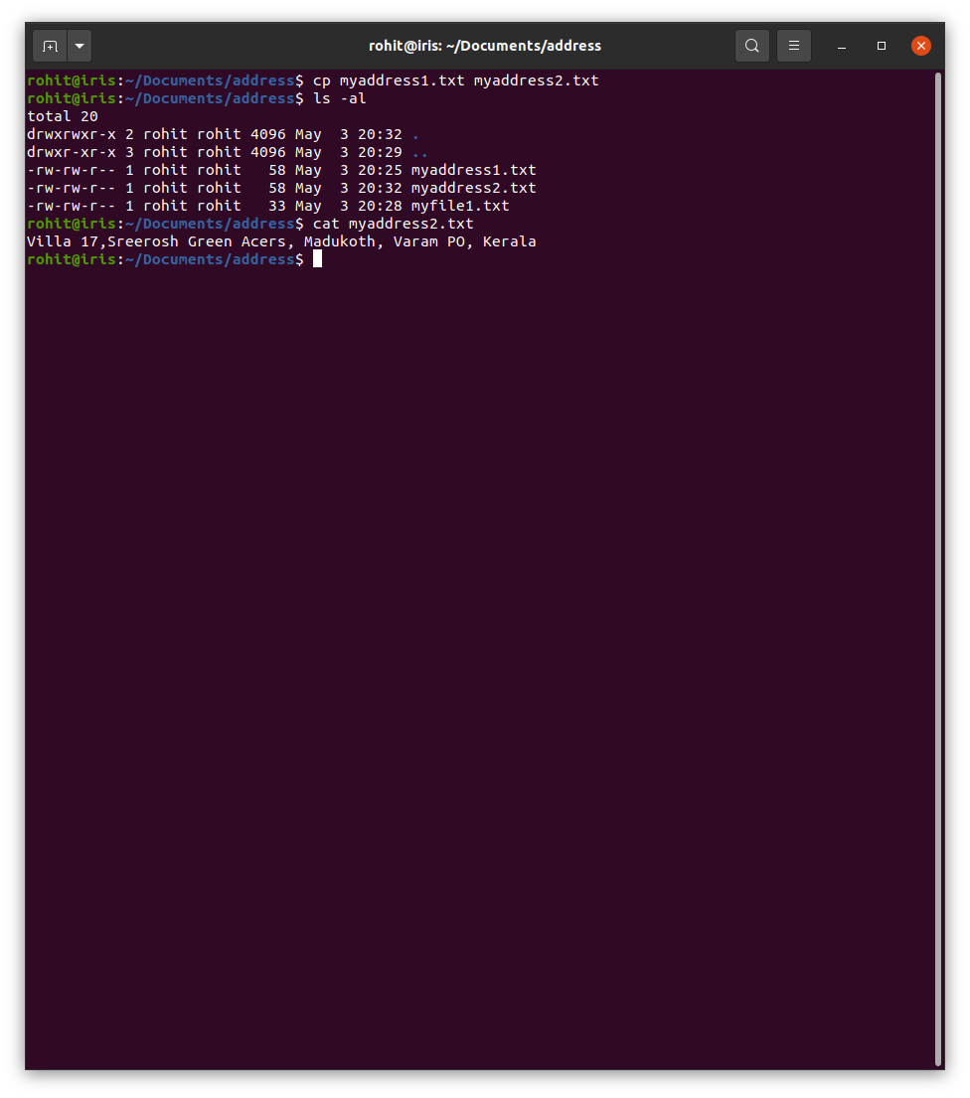
Exerise 5

